**Computer Networks**

Lab Questions

**Program-2**

**Aim:** Implement transmission of ping messages/trace route over a network topology consisting of 6 nodes and find the number of packets dropped due to congestion in the network.

**Steps to be followed:**

Step 1: Click the Activities Panel on the top left side and search for **Terminal**



Step 2: Type the command in the **Terminal**

**java -jar NSG2.1.jar**

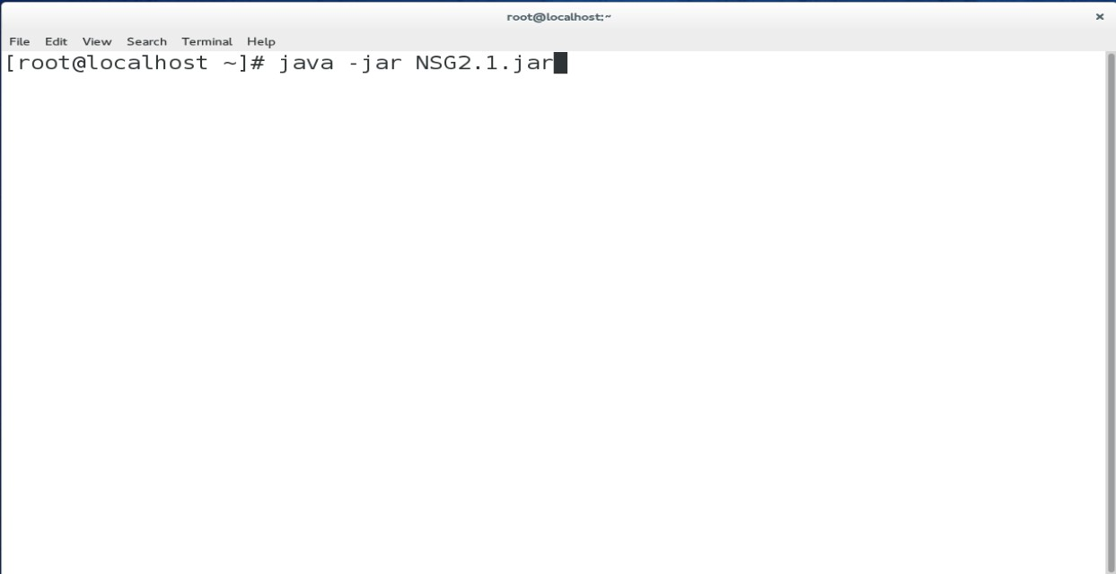

Step 3: Once Entered you will the redirected to a blue screen page there click on

# Scenario -> New wired scenario

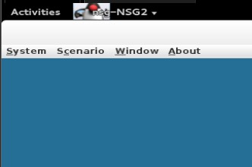 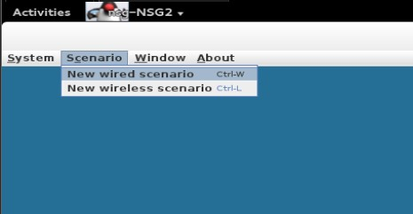

Step 4: Now you will have a blank screen here you must design your topology Click on **Node** and click on the white screen to add the **Node**

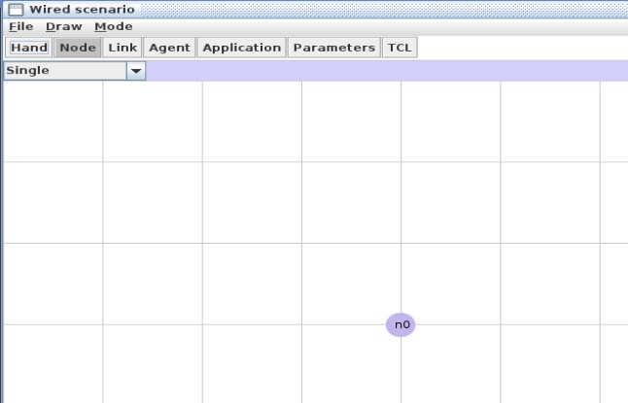

Similarly add 6 nodes as shown below

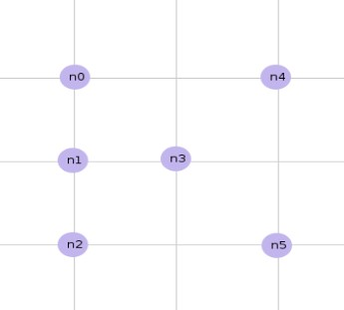

Step 5: Click **Link->duplex-link**  and make the connection from Node n0 to n3, n1 to n3, n2 to n3, n3 to n4 and n3 to n5

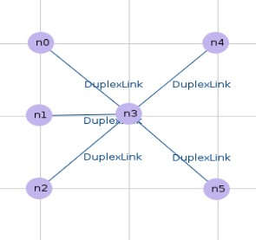

Step 6: Click **Agent->TCP** and click Node n0 and drag to some point make the same for n1

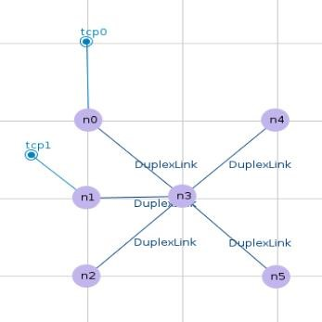

Similary Click **TCPSink** and click Node n4 and drag it and place it some place and do it for Node n5 also

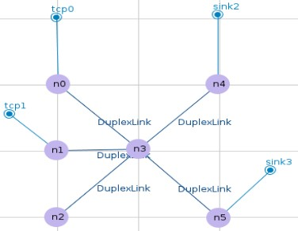

Make the connection by clicking tcp0 and next click sink2 and similarly tcp1 and sink3

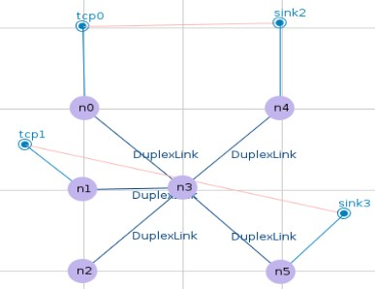

Step 7: Click Parameters and Click save as default and click on TCL and save it. Step 8: Now open the tcl file by entering the following command **gedit exp2.tcl**

Step 9: Make the following changes

#===================================

# Agents Definition

#===================================

Agent/Ping instproc recv {from rtt} {

$self instvar node_

puts "Node [$node_ id] receives response from $from with RTT=$rtt ms" }

#Setup a TCP connection set p0 [new Agent/Ping] $ns attach-agent $n0 $p0 set p3 [new Agent/Ping] $ns attach-agent $n4 $p3

$ns connect $p0 $p3

$p0 set packetSize_ 1500

#Setup a TCP connection set p1 [new Agent/Ping] $ns attach-agent $n1 $p1 set p4 [new Agent/Ping] $ns attach-agent $n5 $p4

$ns connect $p1 $p4

$p1 set packetSize_ 1500

#===================================

# Applications Definition

#===================================

$ns at 1.0 "$p0 send"

$ns at 1.1 "$p0 send"

$ns at 1.2 "$p0 send"

$ns at 1.3 "$p0 send"

$ns at 1.0 "$p1 send"

$ns at 1.1 "$p1 send"

$ns at 1.2 "$p1 send"

$ns at 1.3 "$p1 send"

Step 10: Make a awk code by typing the command **gedit exp2.awk**  and the following line of code to it

BEGIN{

Count=0;

}

{

if($1==”d”)

{

Count++;

}

}

END{

printf(“No. of packets dropped = %d”, Count);

}

Step 11: Now run the Command ns exp2.tcl in the terminal and press the play button

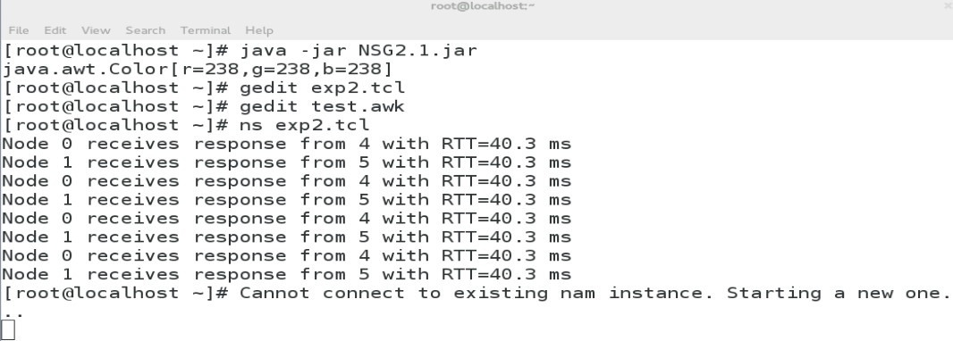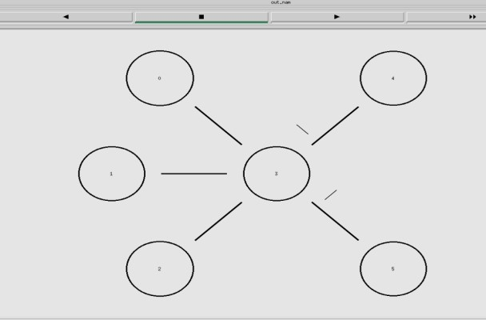

Step 12: Now run the Awk code by the command

**awk -f exp2.awk exp2.tcl**



Step 13: To get dropped packets make the Queue-limit

#===================================

# Links Definition

#===================================

#Createlinks between nodes

$ns duplex-link $n0 $n3 100.0Mb 10ms DropTail

$ns queue-limit $n0 $n3 50

$ns duplex-link $n1 $n3 100.0Mb 10ms DropTail

$ns queue-limit $n1 $n3 50

$ns duplex-link $n2 $n3 100.0Mb 10ms DropTail

$ns queue-limit $n2 $n3 50

$ns duplex-link $n3 $n4 100.0Mb 10ms DropTail

$ns queue-limit $n3 $n4 0

$ns duplex-link $n3 $n5 100.0Mb 10ms DropTail

$ns queue-limit $n3 $n5 50

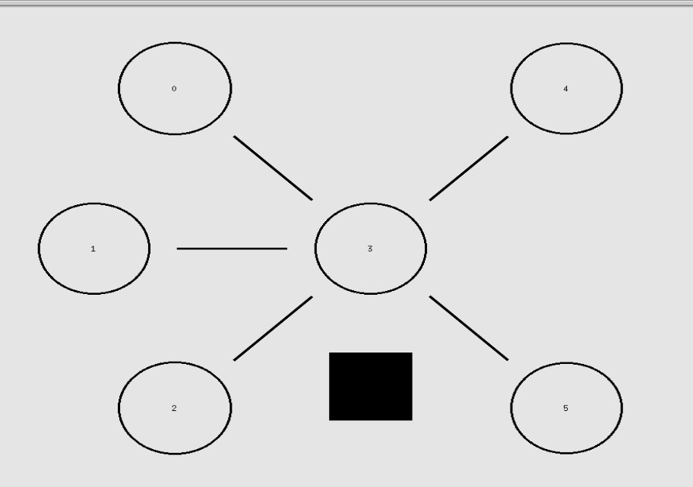

Now run the awk

